Smart Parking System – Database Overview

1. Users Table
Purpose: Stores all registered users (vehicle owners, admins, owners, cashiers).
Key Columns:
- id → Primary key (UUID)
- name, email, phone → Contact info
- role → user/admin/owner/cashier
- created_at → Timestamp of account creation
Notes: Email and phone are unique; used for authentication.

2. Parking Sites Table
Purpose: Stores information about each parking site managed by owners.
Key Columns:
- id → Primary key (UUID)
- owner_id → FK to Users.id
- location → Address/GPS
- capacity → Total slots
- created_at → Timestamp

3. Parking Slots Table
Purpose: Tracks individual slots at each parking site.
Key Columns:
- id → Primary key (UUID)
- slot_number → Label (A1, B2…)
- type → Normal / VIP / Disabled
- is_occupied → True/False
- parking_id → FK to Parking Sites.id
- updated_at → Last update

4. Bookings Table
Purpose: Records parking bookings made by users.
Key Columns:
- id → Primary key (UUID)
- user_id → FK to Users.id
- slot_id → FK to Parking_Slots.id
- vehicle_plate → Vehicle registration
- entry_time, exit_time → Parking times
- payment_status → Paid/Unpaid
- created_at → Timestamp
Notes: exit_time is NULL until the vehicle leaves.

5. Payments Table
Purpose: Tracks payment for each booking.
Key Columns:
- id → Primary key (UUID)
- booking_id → FK to Bookings.id
- amount → Paid amount
- payment_method → Cash / EasyPaisa / Card
- status → Paid / Pending / Refunded
- paid_at → Timestamp (NULL until payment done)

6. AI Logs Table
Purpose: Stores results from License Plate Detection (YOLO) and OCR.
Key Columns:
- id → Primary key (UUID)
- image_url → Path to image in storage
- plate_number → OCR result
- detected_at → Timestamp of detection
- processed_by → YOLO / OCR

Database Relationships (Schema Diagram)

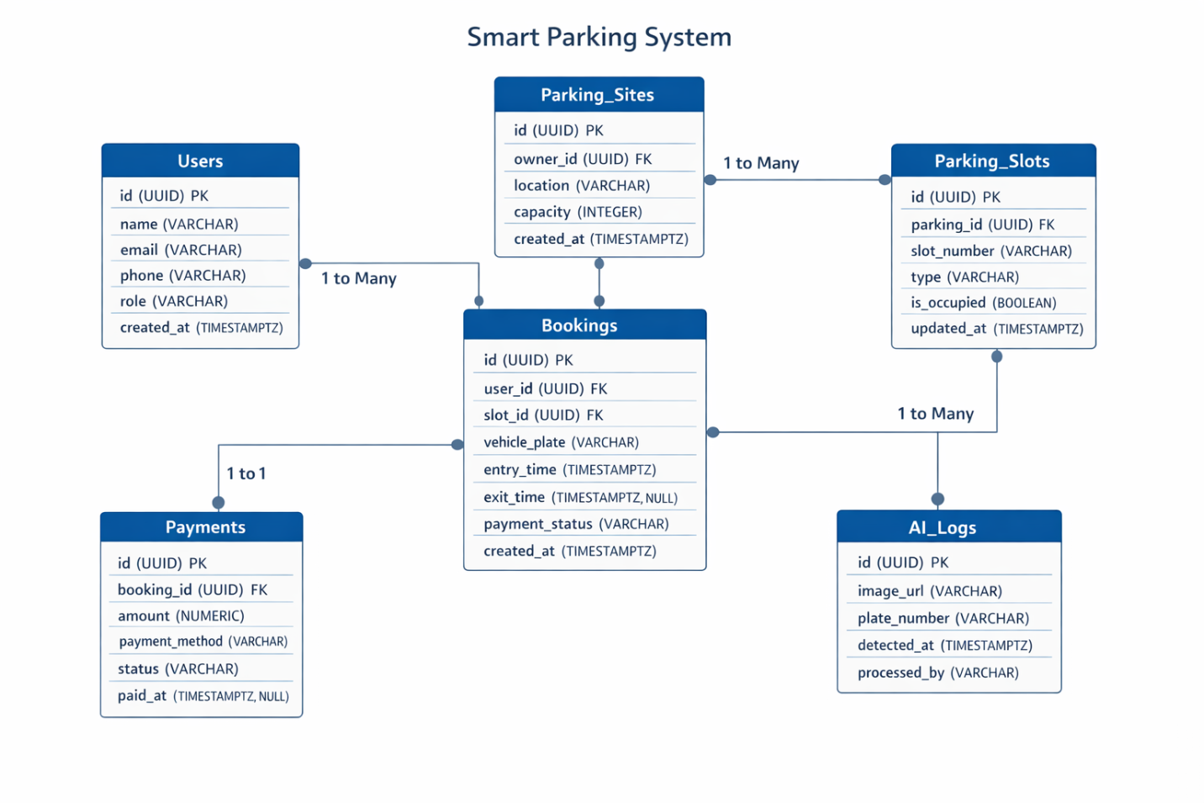

Key Points
- Primary Keys (PK): UUID for global uniqueness.
- Foreign Keys (FK): Link tables to maintain integrity.
- Timestamps: created_at, updated_at, entry_time, exit_time, detected_at, paid_at. Use NOW() default where applicable.
- NULL Columns: exit_time, paid_at (filled later)
- Unique Columns: email, phone, slot_number per site

